# Maciej Piotrowski Lab 3

***Q1. You have 10 disks, each of them with a capacity of 100GB. 8 are fast, with a transfer rate of 1000 Mbits/sec and 2 are slow, with a transfer rate of 500Mbits/sec. Your DB has a stable size of 750 GB.***

Raid 0

1. Usable Space = 1000Gb We need 750gb so we are left with 250GB of free space.
2. Average read access time 15 minutes. 10 disks with 75gb of data on each one. 8 disks with transfer rate of 1000mb/s (75 seconds each) and 2 disks with transfer rate 500mb/s (150 seconds each)

Raid 1

1. Usable space = 500gb as each drive will need another driver to mirror it so it’s not possible to use this solution.

Raid 3

1. Usable space 900gb as one disk will be used for parity disk. 150gb free space.
2. Taking to account that now we have 9 discs that contain 83.3 Gb of data and additional disc with 83.3gb of parity bits. 8 fast discs will take 11.11 min and 2 slower 2.77 min we can assume that average read access will take 16.65 minutes. This exclude computing parity and checking errors.

Raid 5

1. Usable space will decrease as we will have to distribute parity across the discs. Same as in raid 3 we will have to save additional of 83.3gb of data but this time the parity bits will be stored on multiple hard drives.
2. Same read access time as raid 3.

Raid 10

1. We won’t have enough space to store our data as we will lose 50% of our storage capacity

Raid 0+1

1. Same as raid 10. We cannot store 750gb of data where we have only 500gb free space due to mirroring.

***Q2. A RAID 4 configuration (parity disk at block level) is composed by 5 disks + the parity disk. The time for reading a block is 1 second, writing 5 second. The database needs to modify (write):***

1. ***A data spread over 2 blocks in the same stripe***

***List all the operations the RAID system is supposed to do to read the data and modify them taking into account the parity block.***

After writing data into 1st stripe of the 1st block the system needs to update the corresponding 1st stripe of the parity block. Then it needs to move to the 2nd block and repeat the same steps.

1. ***Can you do another write operation at the same time you are performing a) ?***

No as the parity disk needs to be updated before another write operation starts.

1. ***Can you do another read operation at the same time you are performing a) ?***

Yes. As the disk has the hardware controller which enables parallel reads and writes.

***d) How long does operation a) take?***

Assuming we have to write data in to one stripe in two clocks and update the parity block it should take us 20 seconds.

***B-Trees***

***a) Insert into a simple binary tree (it is not a b-tree, there are no balancing rules) the following data (respecting the order of arrivals): 2, 4, 5, 6, 8, 10, 9, 14, 16, 18, 7, 22, 1***

***b) Insert the same data into a B-Tree 2-3 (2 data for each node, 3 pointers, as seen in class).***

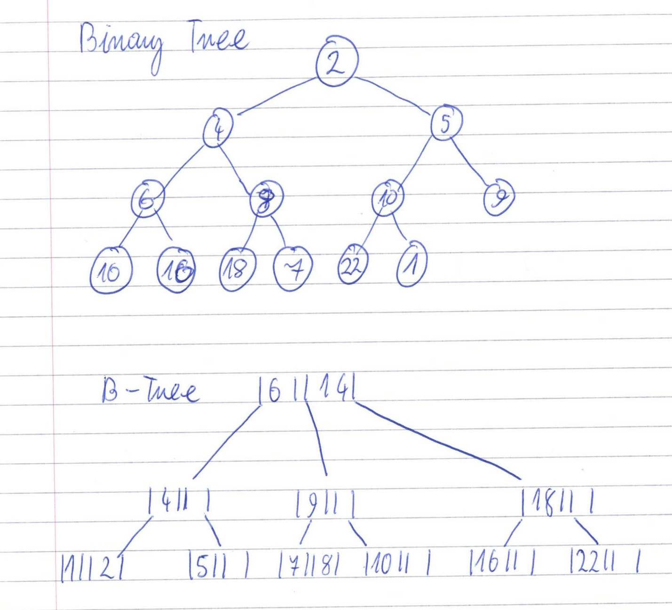

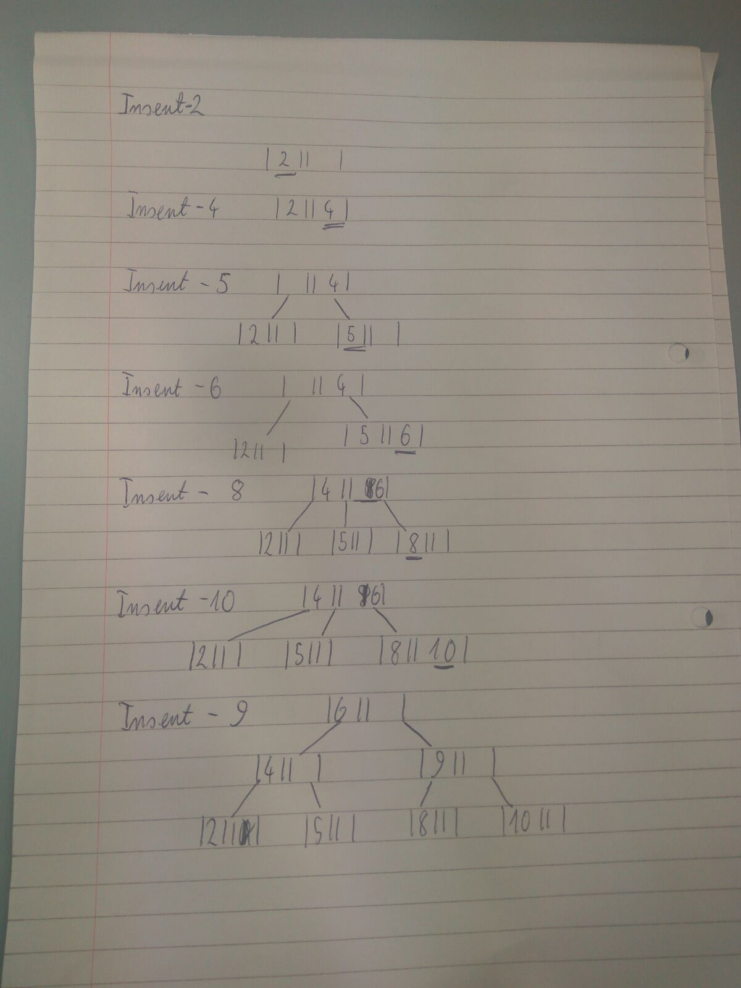

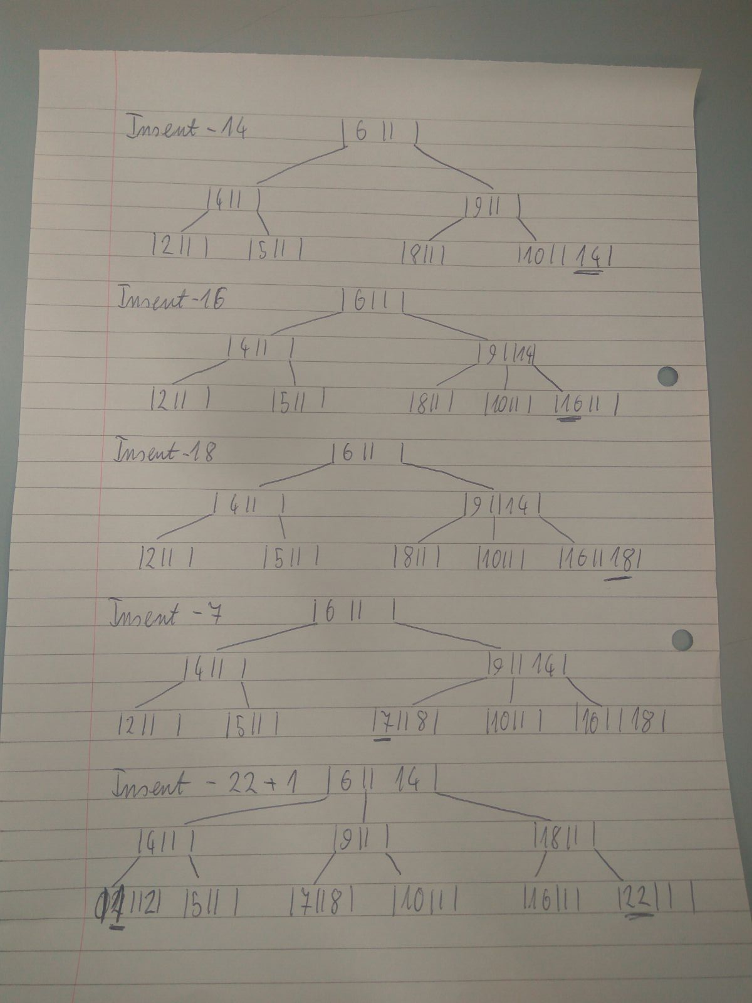

***c) Compare the two trees. Can you see a difference? What is the main advantage of the B-tree?***

Data in binary tree is unsorted whereas B-tree have it sorted and can contain 3 nodes. They are using pointers to data records so it’s easy to find what we are looking for where as in binary tree we have to scan through levels to find the data. (keeps keys in sorted order for sequential traversing)

Q3

DROP TABLE Teams;

DROP TABLE Matches;

CREATE TABLE Matches

(

mactch_id NUMERIC(6) NOT NULL,

teama_id NUMERIC(6) NULL,

teamb_id NUMERIC(6) NULL,

goal_a NUMERIC(2) NULL,

goal_b NUMERIC(2) NULL,

competition VARCHAR(30) NULL

);

ALTER TABLE Matches

ADD PRIMARY KEY (mactch_id);

CREATE TABLE Teams

(

team_id NUMERIC(6) NOT NULL,

team_name VARCHAR(30) NULL,

team_country VARCHAR(30) NULL

);

ALTER TABLE Teams

ADD PRIMARY KEY (team_id);

ALTER TABLE Matches

ADD CONSTRAINT fk_team_a

FOREIGN KEY (teama_id)

REFERENCES Teams(team_id);

ALTER TABLE Matches

ADD CONSTRAINT fk_team_b

FOREIGN KEY (teamb_id)

REFERENCES Teams(team_id);

INSERT INTO Teams VALUES ('1', 'Arsenal', 'England');

INSERT INTO Teams VALUES ('2', 'Manchester United', 'England');

INSERT INTO Teams VALUES ('3', 'Chelsea', 'England');

INSERT INTO Teams VALUES ('4', 'Manchester City', 'England');

INSERT INTO Teams VALUES ('5', 'Barcelona', 'Spain');

INSERT INTO Teams VALUES ('6', 'Real Madrid', 'Spain');

INSERT INTO Teams VALUES ('7', 'Getafe', 'Spain');

INSERT INTO Teams VALUES ('8', 'Sevilla', 'Spain');

CREATE TABLE ltable

(

action VARCHAR(20) NOT NULL,

whenoccured TIMESTAMP NOT NULL

);

CREATE OR REPLACE TRIGGER triger_on_Teams_Table_Insert

AFTER INSERT or UPDATE ON Teams

BEGIN

INSERT into ltable values ('Insertion or update happened on: ', SYSDATE) ;

END;

CREATE OR REPLACE TRIGGER triger_comp

BEFORE INSERT OR UPDATE ON Matches

FOR EACH ROW

BEGIN

IF (:new.competition NOT LIKE 'Champions League' and :new.competition NOT LIKE 'Premier League' and

:new.competition NOT LIKE 'La Liga' and :new.competition NOT LIKE 'Europa Leauge')

THEN

Raise_application_error(-20000,(:new.competition || ' is not recognised '));

END IF;

END;

CREATE OR REPLACE TRIGGER triger_spain_or_england

BEFORE INSERT OR UPDATE ON Teams

FOR EACH ROW

BEGIN

IF (:new.team_country NOT LIKE 'England' and :new.team_country NOT LIKE 'Spain')

THEN

Raise_application_error(-20000,('Please insert England or Spain only!'));

END IF;

END;

CREATE OR REPLACE TRIGGER triger_goals

BEFORE INSERT OR UPDATE ON Matches

FOR EACH ROW

BEGIN

IF (:new.goal_a + :new.goal_b <0)

THEN

Raise_application_error(-20000,('There has to be 0 or more goals in a match'));

END IF;

END;

CREATE OR REPLACE TRIGGER triger_right_league_for_teams

BEFORE INSERT OR UPDATE ON Matches

FOR EACH ROW

BEGIN

IF (:new.competition LIKE 'Premier League')

THEN

IF ((:new.teama_id NOT BETWEEN 1 AND 4) OR (:new.teamb_id NOT BETWEEN 1 AND 4))

THEN

Raise_application_error(-20000,('Only teams from England can play in Premier League'));

END IF;

ELSE IF (:new.competition LIKE 'La Liga')

THEN

IF ((:new.teama_id NOT BETWEEN 5 AND 8) OR (:new.teamb_id NOT BETWEEN 5 AND 8))

THEN

Raise_application_error(-20000,('Only teams from Spain can play in La Liga'));

END IF;

END IF;

END IF;

END;

CREATE OR REPLACE TRIGGER triger_3_matches

BEFORE INSERT OR UPDATE ON Matches

FOR EACH ROW

DECLARE

match_no NUMBER;

BEGIN

SELECT COUNT(*) INTO match_no FROM Matches

WHERE teama_id = :new.teama_id;

IF match_no >= 3

THEN

Raise_application_error(-20000,(:new.teama_id || ' has alredy too many matches '));

END IF;

END;